2026
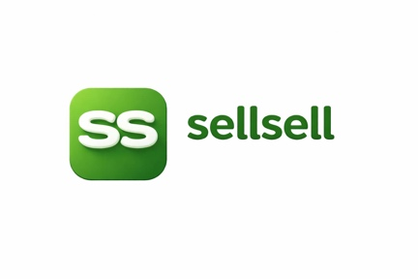
sellsell marketplace updates:

Shaz EJ
Based on the latest development reports you uploaded, here is the current project status as of 20 June 2026:

Completed and Verified
✅ Silent logout issue fixed and deployed
✅ Explore page recommendations fixed and deployed
✅ Admin dashboard crash fixed and deployed
✅ Production deployment completed
✅ End-to-end browser verification completed successfully
✅ Admin Dashboard enhancements completed:
- Listing Moderation Panel
  - Moderation status
  - Indexing status
  - Last agent action
  - Approve / Reject actions
  - Retry moderation
  - Retry indexing
- Demand Capture Dashboard
  - Most requested products
  - Waiting buyers count
  - Categories
  - Price ranges
  - Matched / unmatched status
- Search Analytics
  - Top searches
  - Zero-result searches
  - Arabic vs English searches
  - Category demand
  - Contact click analytics
- User Analytics
  - Total users
  - Active users
  - Sellers
  - Buyers
  - Admins
  - Recent registrations
- UI/UX improvements
  - Loading states
  - Empty states
  - Responsive layouts
  - Summary cards
The reports indicate successful deployment and production verification with a stable environment and all major dashboard features operational.

Estimated Project Status
Core Marketplace Platform: 100%
AI Search: 100%
AI Seller Assistant: 100%
Demand Capture: 100%
Recommendations: 100%
Infrastructure: 100%
Admin Dashboard: 95-100%
Mobile App: ~70%
Notifications: ~80%
Overall Project: ~97% Complete

What Should Be Done Next

Step 1 — Notification System
Complete:
- Email notifications
- Push notifications
- Buyer alerts from Demand Capture
- Seller alerts for inquiries
Estimated: 1–2 days

Step 2 — Mobile App Completion
Focus:
- Seller listing flow
- My Listings
- Chat integration
- Notifications
Estimated: 3–5 days

Step 3 — AI Buyer Agent
Allow users to say:
"I want a black Mercedes S400 under 100,000 QAR"
The AI agent should:
- Search
- Compare
- Recommend
- Explain why it selected products
This is one of the biggest differentiators for SellSell.

Step 4 — Hot Demand Dashboard for Sellers
Show sellers:
- 50 people searching for Toyota Prado
- 30 people searching for iPhone 17
This creates a marketplace growth loop.

Step 5 — Final QA and Load Testing
- Performance testing
- Security testing
- Production stress testing
- Mobile testing

Recommendation
At this stage, I would focus next on:
Notifications → Mobile App → AI Buyer Agent
These three items will provide the biggest business impact and move the platform from a working marketplace to an AI-powered marketplace ready for commercial launch.

